Third Grade Paper Lesson Packet
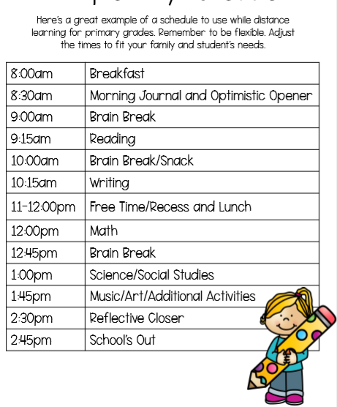

Begin your day with deep breaths and thoughtful intentions. You can even try out a yoga pose or two!
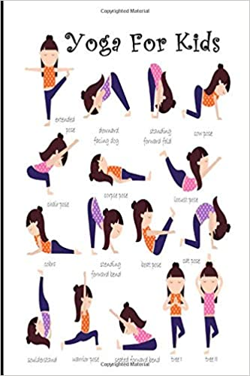

Please complete one journal entry each day. Use the sheet below to write your journal entry. Choose from:
- What would you tell your teenage self?
- What is a good characteristic for a person to have?
- What is a favorite memory you have?
- Tell me about someone who helped you this week.
- How many games can you list?
- You can choose one day to free write any topic of your choice.

Read fiction and/or nonfiction books (picture books, chapter books, or a combination) independently for at least 30 minutes per day and complete the At Home Reading Log. Use the Reading Choice Board to write about the books you have chosen to read. This week, read an AR book and complete the Story Map below:

Name:_________________________
Title

Characters

Problem

Conclusion

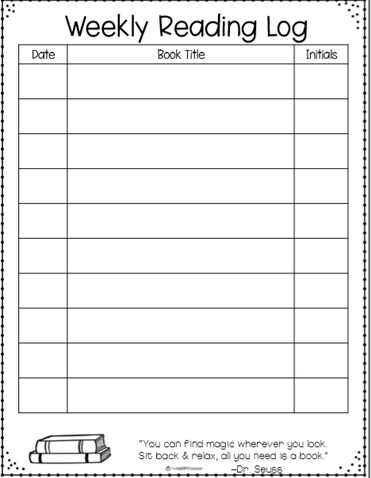

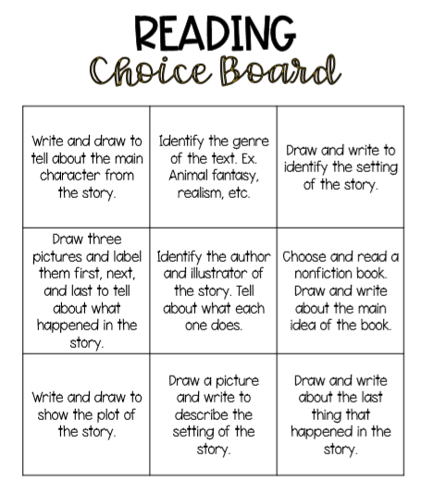

Each day choose a writing topic from the Writing Choice Board
Create a book | Write a poem about the weather | Write a personal narrative about a location you visited that taught you a lot
Create a comic strip | Free Write | List as many facts about an animal as you can
Compare and contrast dogs and cats using a Venn Diagram | Describe your neighborhood | List as many proper nouns as you can

Vocabulary Activity:
Complete one personal dictionary entry each day using one of your independent fiction or nonfiction books (picture book or chapter book). Students can (optional) also create fun, detailed sentences with their new words. See how many different parts of speech you can use-can it be a noun? A verb? An adjective? An adverb? Draw a picture of what each of your sentences describes.

Math: Choose 3 squares to complete from the Math Choice Board.

Math Game of the Week:  Deal out regular playing cards and add them together. This can be played alone or with a partner. | Fractions  Draw and label five different fractions using a picture as a model. | Dice Game  Roll two dice and multiply the two numbers. Complete 20 rolls with your dice.
Place Value Game  Create a T Chart with 1s, 10s, 100s, etc…and then make the largest number you can. Repeat. | Free math choice | Fractions  Draw and label five different fractions between 0 and 1 using a number line.
Flash Cards  Create your own set of flash cards using multiplication or division problems. | Create your own math game! | Prodigy

Additional Activity: Go outside at three different times of the day (morning, afternoon, evening). Draw and/or label or write about what you see in the sky. Answer the following questions on paper or discuss with an adult:
• What was the weather like?
• How does weather affect the earth?
• What happens to things like mountains, rocks, and dirt when it rains or there are high winds?
• What kinds of animals are able to survive in the weather we have here in Nevada?

Social Studies: List 10 state capitals.
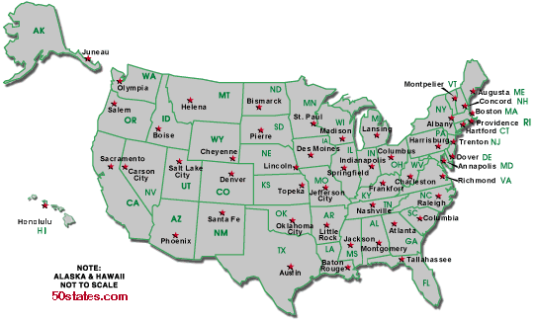
SEL (Social and Emotional Learning)
(CHOOSE ONE EACH DAY)
• Why is it important to be positive? What impact does it have on you and others?
• Think of your favorite book, movie, or TV show; how do some of the characters care for others in the story? Tell a friend or journal about it.
• Reflect on your day: Write down all the times you helped someone today. See how long of a list you can make. Acts of kindness can be simple and easy!
• Trace your hand on a paper. In the fingers, write 5 compassion words. In the palm, draw what your favorite word for kindness looks like.
• Reflection: How has compassion shaped your words and actions this week? What acts of compassion did you use this week? How did they impact others around you? How did they make you feel?

