Third Grade Paper Lesson Packet
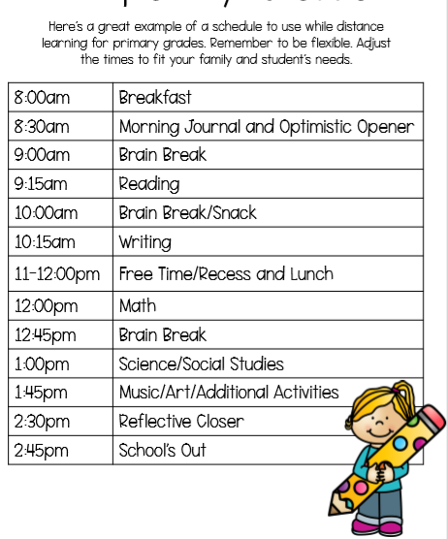

Begin your day with deep breaths and thoughtful intentions. You can even try out a yoga pose or two!
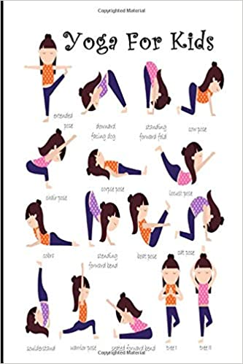

Please complete one journal entry each day. Use the sheet below to write your journal entry. Choose from:
- Write about your favorite toy,
- Write about the best day of your life,
- Describe an made up dream or nightmare,
- Write a note to a friend who gave you garlic and onion favored chewing gun,
- You can choose one day to free write any topic of your choice.

Read fiction and/or nonfiction books (picture books, chapter books, or a combination) independently for at least 30 minutes per day and complete the At Home Reading Log. Use the Reading Choice Board to write about the books you have chosen to read. This week, read an AR book and complete the Story Map below:

Name:_________________________
Title

Characters

Problem

Conclusion

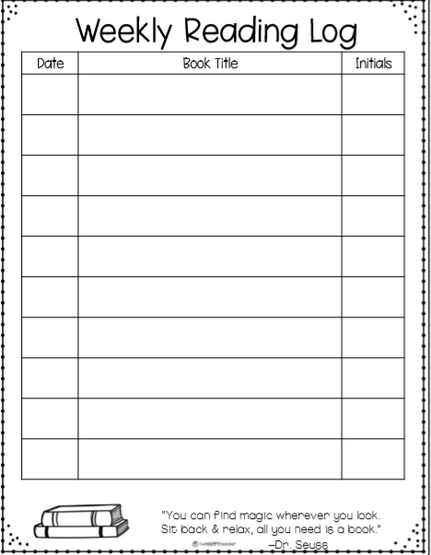

Write and draw to tell about the main character from the story | Identify the genre of the text. Ex: Animal Fantasy, etc. | Draw and write to identify the setting of the story
Draw three pictures and label them first, next and last to tell about what happened in the story | Identify the author and illustrator of the story. Tell about what each one does. | Choose and read a nonfiction book. Draw and write about the main idea of the book.
Write and draw to show the plot of the story. | Draw a picture and write about the setting of the story. | Draw and write about the last thing that happened in the story.

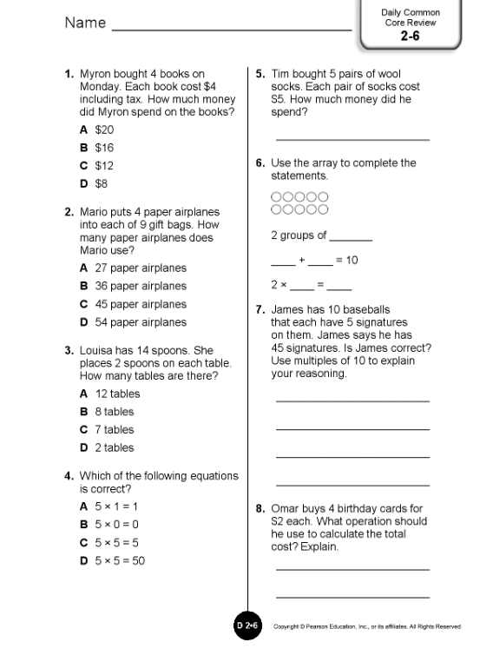

Each day choose a writing topic from the Writing Choice Board
Create a book | Write a poem about the weather | Write a personal narrative about a location you visited that taught you a lot
Create a comic strip | Free Write | List as many facts about an animal as you can
Compare and contrast dogs and cats using a Venn Diagram | Describe your neighborhood | List as many proper nouns as you can

Vocabulary Activity:
Complete one personal dictionary entry each day using one of your independent fiction or nonfiction books (picture book or chapter book). Students can (optional) also create fun, detailed sentences with their new words. See how many different parts of speech you can use-can it be a noun? A verb? An adjective? An adverb? Draw a picture of what each of your sentences describes.

Math: Choose 3 squares to complete from the Math Choice Board.

Math Game of the Week:  Deal out regular playing cards and add them together. This can be played alone or with a partner. | Fractions  Draw and label five different fractions using a picture as a model. | Dice Game  Roll two dice and multiply the two numbers. Complete 20 rolls with your dice.
Place Value Game  Create a T Chart with 1s, 10s, 100s, etc…and then make the largest number you can. Repeat. | Free math choice | Fractions  Draw and label five different fractions between 0 and 1 using a number line.
Flash Cards  Create your own set of flash cards using multiplication or division problems. | Create your own math game! | Prodigy  Or  Khan Academy

Science
Weather
Materials: Blank Paper (8.5 x 11”), Scissors, Dot Dtickers, Paper Clips, Toothpicks
Prep Instructions:
Students first need one paper clip and two dot stickers to build their paper house model. For the second part of the activity, each pair will need a blank sheet of paper, six toothpicks, four paper clips, and two dot stickers to design a solution that prevents their house from blowing over in the wind.
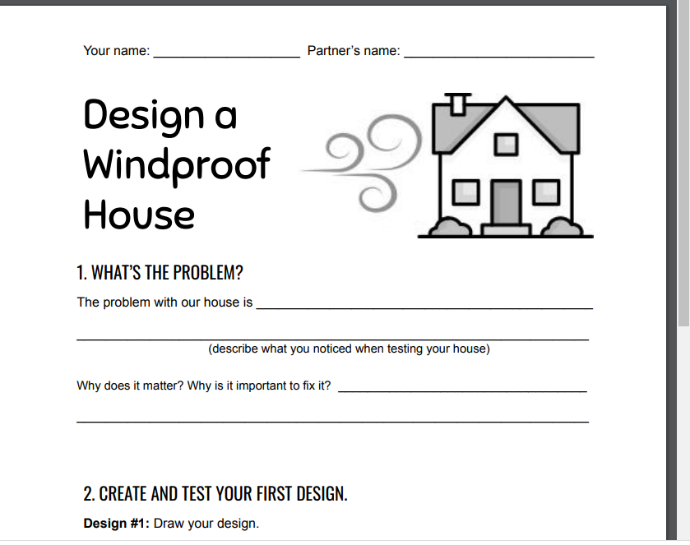

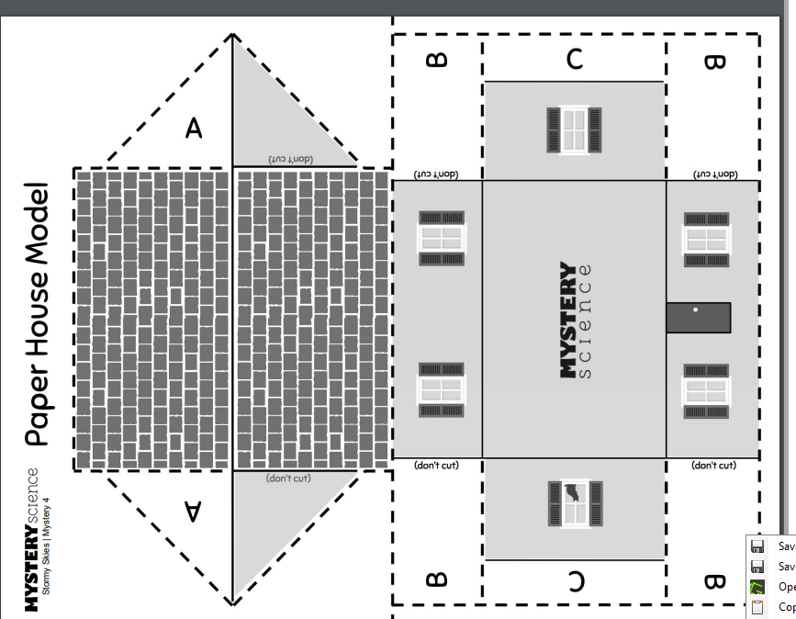

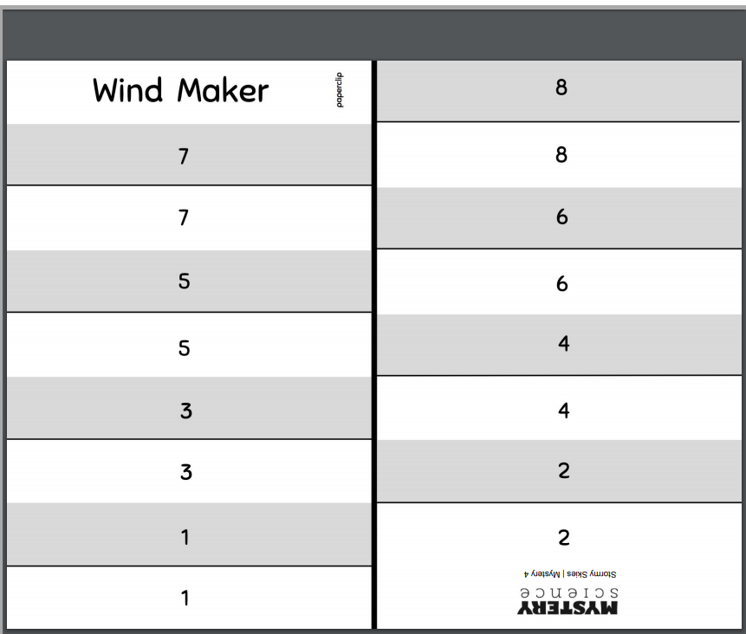
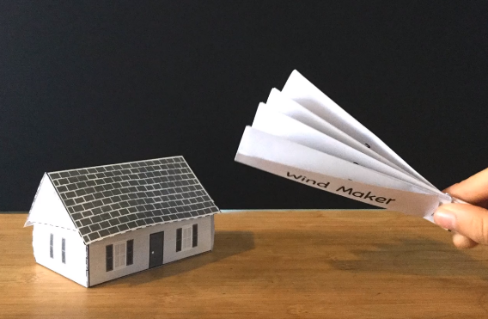

Additional Activity: Research lightning and thunder. Then write a paragraph to a friend about why lightning and thunder occurs. Let your friend know why thunder often follows lightening.

Social Studies: List all 50 states and their capitals.
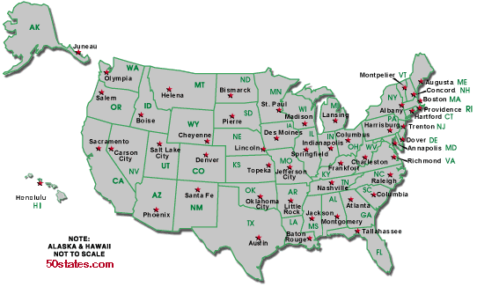
SEL (Social and Emotional Learning)
(CHOOSE ONE EACH DAY)
• Why is it important to be helpful? What impact does it have on you and others?
• Think of your favorite book, movie, or TV show; how do some of the characters help others in the story? Tell a friend or journal about it.
• Reflect on your day: Write about how you helped someone today.
• Trace your hand on a paper. In the fingers, write 5 words about assisting. In the palm, draw what your favorite word for being helpful looks like.
• Reflection: How has helping others shaped your words and actions this week? What acts of assistance did you use this week? How did they impact others around you? How did they make you feel?

