WEEK 3
3RD GRADE | Week 3
JOURNAL & BREAKFAST | Morning Meditation: Fun with relaxation:  Visit www.cosmicyoga.com  Optional App: Breathekids.com  Visit Go-Noodle and search under the mindfulness channel https://family.gonoodle.com/activities/from-mindless-to-mindful  Please complete one journal entry each day. Choose from: What would you tell your teenage self? What is a good characteristic for a person to have? What is a favorite memory you have? Tell me about someone who helped you this week, how many games can you list and you can choose one day to free write any topic of your choice.
LITERACY | Read fiction and/or nonfiction books (picture books, chapter books, or a combination) independently for at least 30 minutes per day and complete the At Home Reading Log. Use the Reading Choice Board to write about the books you have chosen to read. This week, read an AR book and complete the Story Map below:  Name:_________________________  Title  Characters  Problem  Conclusion  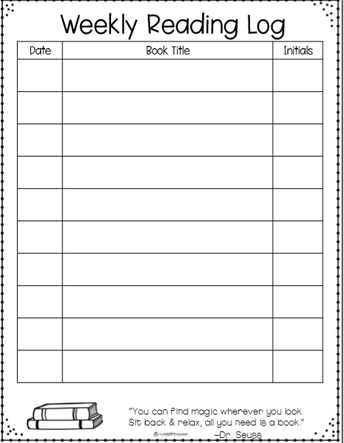  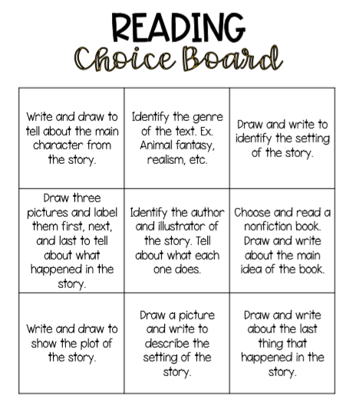  Read-alouds can be found on www.storylineonline.net. Options for books – books you have around the house, Libby (online Washoe Co. library app), Benchmark materials that have been brought home, log in to Clever to read your Benchmark books online, newspapers, magazines. Clever for Benchmark books online,  https://bit.ly/3acVAPc
SCAFFOLDS/  SUPPORTS AND ACCOMMODATIONS | Students can dictate to someone, label pictures, make a list, copy key details from the text, sequence of events, create story questions (like AR questions), and/or write complete sentences.
WRITING  VOCABULARY | Each day choose a writing topic from the Writing Choice Board.  Create a book Write a poem about the weather Write a personal narrative about a location you visited that taught you a lot  Create a comic strip Free Write List as many facts about an animal as you can  Compare and contrast dogs and cats using a Venn Diagram Describe your neighborhood List as many proper nouns as you can  Vocabulary Activity:  Complete one personal dictionary entry each day using one of your independent fiction or nonfiction books (picture book or chapter book). Students can (optional) also create fun, detailed sentences with their new words. See how many different parts of speech you can use-can it be a noun? A verb? An adjective? An adverb? Draw a picture of what each of your sentences describes.
MATH | Math Activities:  Log on to Khan Academy and Join Our Class!  Additional Activity:  Experiment in the kitchen. Pick a recipe that has fractions and observe the measuring cup. How many ½ cups does it take to equal a whole cup? How many ¼ cups does it take to equal a whole cup? What might you do if you needed to measure two cups but did not have a two cup measure? Do not limit yourself to fractions; take this opportunity to discuss addition and subtraction too!
SCIENCE AND SOCIAL STUDIES | Science Mystery: Weather: https://mysteryscience.com/weather/weather-climate  Additional Activity: Go outside at three different times of the day (morning, afternoon, evening). Draw and/or label or write about what you see in the sky. Answer the following questions on paper or discuss with an adult:  • What was the weather like?  • How does weather affect the earth?  • What happens to things like mountains, rocks, and dirt when it rains or there are high winds?  • What kinds of animals are able to survive in the weather we have here in Nevada?  Social Studies: List 10 state capitals. https://www.google.com/url?sa=i&url=https%3A%2F%2Fwww.50states.com%2Fcap.htm&psig=AOvVaw2pTuA2QM4IJcJrFb2DKnA-&ust=1586376636902000&source=images&cd=vfe&ved=0CAIQjRxqFwoTCOD2ttSP1-gCFQAAAAAdAAAAABAM  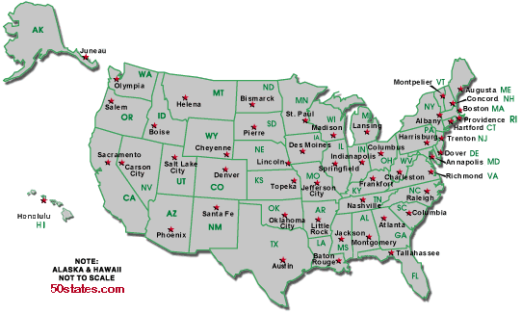
SEL (Social and Emotional Learning) AND MUSIC | (CHOOSE ONE EACH DAY)  • Why is it important to be positive? What impact does it have on you and others?  • Think of your favorite book, movie, or TV show; how do some of the characters care for others in the story? Tell a friend or journal about it.  • Reflect on your day: Write down all the times you helped someone today. See how long of a list you can make. Acts of kindness can be simple and easy!  • Trace your hand on a paper. In the fingers, write 5 compassion words. In the palm, draw what your favorite word for kindness looks like.  • Reflection: How has compassion shaped your words and actions this week? What acts of compassion did you use this week? How did they impact others around you? How did they make you feel?
Enrichment | Enrichment: Optional: Choose 3 squares to complete from the Math Choice Board.  Math Game of the Week: Strive to Drive: https://www.washoeschools.net/cms/lib/NV01912265/Centricity/domain/1597/distance%20learning/elementary/4-1%20new%20es/grades%203-5/Week%203%207%204.G2StriveDerive.pdf Four Strikes and You’re Out: http://www.marilynburnsmathblog.com/four-strikes-and-youre-out/ Fractions Draw and label five different fractions using a picture as a model. Dice Game Roll two dice and multiply the two numbers. Complete 20 rolls with your dice.  Place Value Game Create a T Chart with 1s, 10s, 100s, etc…and then make the largest number you can. Repeat. Prodigy Fractions Draw and label five different fractions between 0 and 1 using a number line.  Flash Cards Create your own set of flash cards using multiplication or division problems. Create your own math game! Coding Scratch.mit.edu https://scratch.mit.edu/projects/editor/?tutorial=home

