WEEK 4
3RD GRADE | Week 3
JOURNAL & BREAKFAST | Morning Meditation: Fun with relaxation:  Visit www.cosmicyoga.com  Optional App: Breathekids.com  Visit Go-Noodle and search under the mindfulness channel https://family.gonoodle.com/activities/from-mindless-to-mindful  Please complete one journal entry each day. Choose from Write about your favorite toy, Write about the best day of your life, Describe an made up dream or nightmare, Write a note to a friend who gave you garlic and onion favored chewing gun, and you can choose one day to free write any topic of your choice.
LITERACY | Read fiction and/or nonfiction books (picture books, chapter books, or a combination) independently for at least 30 minutes per day and complete the At Home Reading Log. Use the Reading Choice Board to write about the books you have chosen to read. This week, read an AR book and complete the Story Map below:  Name:_________________________  Title  Characters  Problem  Conclusion  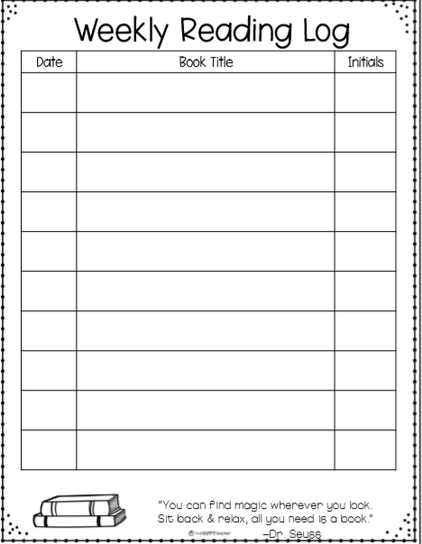  Write and draw to tell about the main character from the story Identify the genre of the text. Ex: Animal Fantasy, etc. Draw and write to identify the setting of the story  Draw three pictures and label them first, next and last to tell about what happened in the story Identify the author and illustrator of the story. Tell about what each one does. Choose and read a nonfiction book. Draw and write about the main idea of the book.  Write and draw to show the plot of the story. Draw a picture and write about the setting of the story. Draw and write about the last thing that happened in the story.  Read-alouds can be found on www.storylineonline.net. Options for books – books you have around the house, Libby (online Washoe Co. library app), Benchmark materials that have been brought home, log in to Clever to read your Benchmark books online, newspapers, magazines. Clever for Benchmark books online,  https://bit.ly/3acVAPc
SCAFFOLDS/  SUPPORTS AND ACCOMMODATIONS | Students can dictate to someone, label pictures, make a list, copy key details from the text, sequence of events, create story questions (like AR questions), and/or write complete sentences.
WRITING  VOCABULARY | Each day choose a writing topic from the Writing Choice Board.  Create a book Write a poem about a dog or cat Write a letter to a person living in a different country  Create a comic strip Free Write List as many facts about an gardening as you can  Compare and contrast forest and beach a Venn Diagram Describe where you live (either inside or outside) List as many plural nouns as you can  Vocabulary Activity:  Complete one personal dictionary entry each day using one of your independent fiction or nonfiction books (picture book or chapter book). Students can (optional) also create fun, detailed sentences with their new words. See how many different parts of speech you can use-can it be a noun? A verb? An adjective? An adverb? Draw a picture of what each of your sentences describes.
MATH | Math Activities:  Log on to Khan Academy and Join Our Class!  This week type the following topic titles into the search bar to practice:  Comparing fractions with the same denominator  Video  (Opens in a new window)  From <https://www.khanacademy.org/math/cc-third-grade-math/equivalent-fractions-and-comparing-fractions/imp-comparing-fractions/v/comparing-fractions-with-the-same-denominator-math-3rd-grade-khan-academy>  Compare fractions with the same numerator  From <https://www.khanacademy.org/math/cc-third-grade-math/equivalent-fractions-and-comparing-fractions/imp-comparing-fractions/e/comparing_fractions_with_the_same_numerator>  Compare fractions with the same numerator  Exercise · Different question set  From <https://www.khanacademy.org/coach/class/4769752334614528/manage-assignments>  Comparing fractions: number line  From <https://www.khanacademy.org/math/4th-engage-ny/engage-4th-module-5/4th-module-5-topic-c/v/comparing-fractions-on-a-number-line>  https://www.khanacademy.org/math/4th-engage-ny/engage-4th-module-5/4th-module-5-topic-c/v/comparing-fractions-on-a-number-line  Optional: Check out coding on Khan Academy! Just choose Start here! In Khan Academy  https://www.khanacademy.org/coach/class/6633513128968192/exercises>  Additional Activity:  Choose 3 squares to complete from the Math Choice Board.  Explore Khan Academy Fractions Draw and label five different fractions using a picture as a model. Dice Game Roll two dice and multiply the two numbers. Complete 20 rolls with your dice.  Place Value Game Create a T Chart with 1s, 10s, 100s, etc…and then make the largest number you can. Repeat. Prodigy Fractions Draw and label five different fractions between 0 and 1 using a number line.  Flash Cards Create your own set of flash cards using multiplication or division problems. Create your own math game! Coding Scratch.mit.edu https://scratch.mit.edu/projects/editor/?tutorial=home
SCIENCE AND SOCIAL STUDIES | Science Mystery: Weather: https://mysteryscience.com/weather/weather-climate  Finish this four part project by Friday 04/17/20  Additional Activity: Research lightning and thunder. Then write a paragraph to a friend about why lightning and thunder occurs. Let your friend know why thunder often follows lightening.  Social Studies: List all 50 states and their capitals. https://www.google.com/url?sa=i&url=https%3A%2F%2Fwww.50states.com%2Fcap.htm&psig=AOvVaw2pTuA2QM4IJcJrFb2DKnA-&ust=1586376636902000&source=images&cd=vfe&ved=0CAIQjRxqFwoTCOD2ttSP1-gCFQAAAAAdAAAAABAM  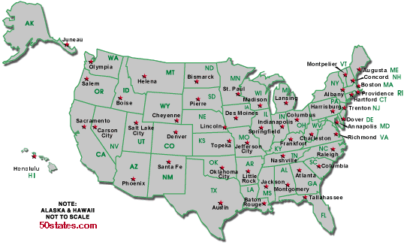
SEL (Social and Emotional Learning) AND MUSIC | (CHOOSE ONE EACH DAY)  • Why is it important to be helpful? What impact does it have on you and others?  • Think of your favorite book, movie, or TV show; how do some of the characters help others in the story? Tell a friend or journal about it.  • Reflect on your day: Write about how you helped someone today.  • Trace your hand on a paper. In the fingers, write 5 words about assisting. In the palm, draw what your favorite word for being helpful looks like.  • Reflection: How has helping others shaped your words and actions this week? What acts of assistance did you use this week? How did they impact others around you? How did they make you feel?

